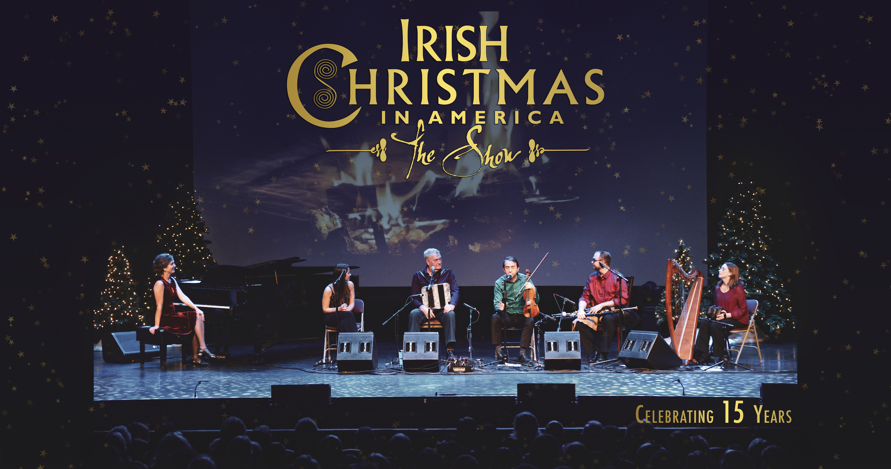
www.irishchristmasinamerica.com

A Captivating Show Featuring Top Irish Talent

“Captivating” Irish Music Magazine

“Lively and reflective...a powerful evocation of the season” Folk Wax

“Irish Christmas in America admirably refuses to pander to the lowest common denominator. By doing so, they all convey the spirit of the season with uncommon taste and integrity.” Irish Echo

“Full of exceptional music and dance, relaxed good humor, and interesting historical commentary, "Irish Christmas in America is one of the few standouts. It was as relaxed and enjoyable as any Irish Christmas-themed concerts I’ve ever attended.” Irish Echo

Back for a 18th season, the hugely popular holiday show “Irish Christmas in America” brings a fascinating performance of music, song, dance and stories of seasonal Irish traditions.

Publicist: Brendan Gilmartin, Chart Room Media
(347) 450-3048 brendan@chartroommedia.com

2023 Show

Irish Christmas in America
Produced by Sligo fiddler Oisín Mac Diarmada, the hugely popular Irish Christmas in America show features top Irish music, song and dance in an engaging performance rich in humour and boundless energy. The 2023 tour features the return of vocalist Caitríona Sherlock, a stunning example of the very best of new Irish female vocal talent.

This family-friendly performance features lively instrumental tunes on fiddle, flute, uilleann pipes and harp, along with thrilling Irish old-style dancing from Samantha Harvey. In addition, evocative photographic images provide a backdrop to some of the rich historical traditions of Ireland. Take a memorable glimpse into the enchanting spirit of Christmas, as the finest traditional artists from Ireland, bring you on a fun-filled start to the holiday season of 2023.

Show Origins
The holiday show was first conceived in 2005 with past tours featuring such stellar guest vocalists as Niamh Farrell, Séamus & Méabh Begley, Teresa Horgan, Lumiere (Pauline Scanlon & Eilis Kennedy), Karan Casey, Cara Dillon, Muireann Nic Amhlaoibh, Cathie Ryan and Michael Londra. Mac Diarmada enthuses about the program as a way to bring traditional and often unknown Irish customs to the States. “One of the most heartfelt themes of Irish Christmas is emigration,” says Mac Diarmada. “Music was a way that people stayed close to home.”

A sparkling tradition among holiday events, Irish Christmas in America is a special show to see this season. For more information visit irishchristmasinamerica.com.

Performance Venues 2005-2022 include:
* Cerritos Performing Arts Center, Los Angeles * The Dana Center, NH
* National Geographic Live! Washington DC * Fox Theater, Tucson AZ * The Egg Albany
* Annenberg Center Philadelphia * Kimo Theater, NM * Dixie State University, UT

Selected Individual Biographies

Caitríona Sherlock – vocals
Caitríona Sherlock, a talented young singer from Monaghan, came to attention when winning All-Ireland titles for singing in 2013 & 2017. Since then, she has gone on to perform internationally with Choral Scholars of University College Dublin, appearing frequently alongside Ireland’s leading instrumentalists and orchestras. Caitríona brings to Irish Christmas in America a magical voice and stage presence, invoking the warmth and charm of an Irish Christmas evening.

Oisín Mac Diarmada – producer / fiddle
A graduate in Music Education from Trinity College Dublin/RIAM, Oisín has been described by The Irish Echo's Earle Hitchner as "one of the most gifted and creative traditional fiddlers playing today." Founder of noted group Téada, Oisín is also a regular solo performer, having appeared as guest soloist with the Southern Georgia Symphony Orchestra (USA) and Würtembergische Philharmonie Orchestra (Germany) along with an extensive recording history.

Gráinne Hambly – Irish harp /concertina
Gráinne Hambly from County Mayo in the West of Ireland is an internationally recognised exponent of the Irish harp. In 1998 she completed a Masters Degree in Musicology at Queen's University Belfast, for which her main research topic was music collections and the harp in 18th-century Ireland. Since then, Gráinne has toured extensively throughout Europe and the United States, giving concerts, workshops and masterclasses.

Samantha Harvey - dance / piano
Samantha Harvey is an award-winning step dancer, pianist and accordionist. She has performed throughout the world. Samantha performed in RTÉ's Centenary 2016, broadcast live from the Bord Gáis Energy Theatre in Dublin and with the Omaha Symphony in A Celtic Journey.

Sean Gavin - flute / uilleann pipes
Seán Gavin’s ornate and driving style on the flute and uilleann pipes reflects his lifelong immersion in traditional Irish music. Despite his young age, he is already an accomplished performer having toured extensively on three continents. Currently residing in St. Paul MN, he remains firmly dedicated to playing and teaching traditional Irish music. Seán is a member of the group Bua, and often performs with his family.

Patrick Doocey - guitar
Patrick Doocey from Foxford, Co. Mayo is quickly becoming one of the most in demand accompanists on the Irish music scene today. Predominately self-taught on guitar, Patrick’s exciting style on both nylon and steel string guitar combines influences from many genres including jazz, hip hop, r n b and rock. His talents can be heard on Lunasa’s latest release “Cas” as well on recent albums with Kevin Crawford, Dylan Foley and Colin Farrell.

